|  |  |
| --- | --- |
| Merge sort Algorthim | Student Evaluation  **20213939 Ahmed Yasser Ahmed**  **20213854MohamedAlaaeldin**  **20210489 Ziad Khaled Hamdy**  **Professor: Wael Hassan**  **TA: Dina Ayman** |

**Introduction:**

**Merge sort is a widely used comparison-based sorting algorithm known for its efficiency and stability. It follows the divide-and-conquer paradigm, breaking down the original list into smaller sub lists until each sub list contains only one element, then merging those sub lists in a sorted manner to produce the final sorted list. Merge sort guarantees a time complexity of O (n log n) for sorting n elements, making it suitable for large datasets.**

**Example with Solution:**

**Consider sorting the array [15,10,23,7,9,17,6,12] using the merge sort algorithm.**

**Step 1: Divide the array.**

|  |  |  |  |
| --- | --- | --- | --- |
| **15** | **10** | **23** | **7** |

|  |  |  |  |
| --- | --- | --- | --- |
| **9** | **17** | **6** | **12** |

**Step 2: Recursively sort**

|  |  |  |  |
| --- | --- | --- | --- |
| **7** | **10** | **15** | **23** |

|  |  |  |  |
| --- | --- | --- | --- |
| **6** | **9** | **12** | **17** |

**Step 3: Merge the sorted.**

|  |  |  |  |  |  |  |  |
| --- | --- | --- | --- | --- | --- | --- | --- |
| **6** | **7** | **9** | **10** | **12** | **15** | **17** | **23** |

**This results in sorted.**

|  |  |  |  |  |  |  |  |
| --- | --- | --- | --- | --- | --- | --- | --- |
| **6** | **7** | **9** | **10** | **12** | **15** | **17** | **23** |

**GUI Tools and Steps:**

**JavaFX:** is a free and open-source toolkit for building modern applications. It lets you create visually appealing and interactive programs for desktops, mobile devices, and even embedded systems, all using the familiar Java programming language.

**Scene Builder:** Scene Builder is a visual layout tool often included in GUI development frameworks. It allows you to drag-and-drop UI elements like buttons, text fields, and layouts to create the visual structure of your application's interface.

**Buttons:** Buttons are clickable elements that trigger an action when pressed. They are commonly used to initiate commands, submit data, or navigate within an application.

**Text Field:** A text field is a single-line input area where users can enter and edit text. It's useful for collecting short, specific pieces of information like names, usernames, or numbers.

**Scroll Pane:** A scroll pane is a container that allows users to view content that is larger than the available display area. It provides scrollbars that enable users to navigate through the hidden content.

**VBox:** A VBox, short for vertical box, is a layout container that arranges its child elements vertically one below the other. It's helpful for creating stacked lists, forms, or any UI element where a vertical order is desired.

**Text Area:** A text area is a multi-line input area where users can enter and edit extended text. It's suitable for writing paragraphs, descriptions, or any content that requires more than a single line.

**Labels:** Labels are text elements that provide descriptive information or instructions within an interface. They don't respond to user interaction but help explain the purpose of other UI components.

**Screenshots:**

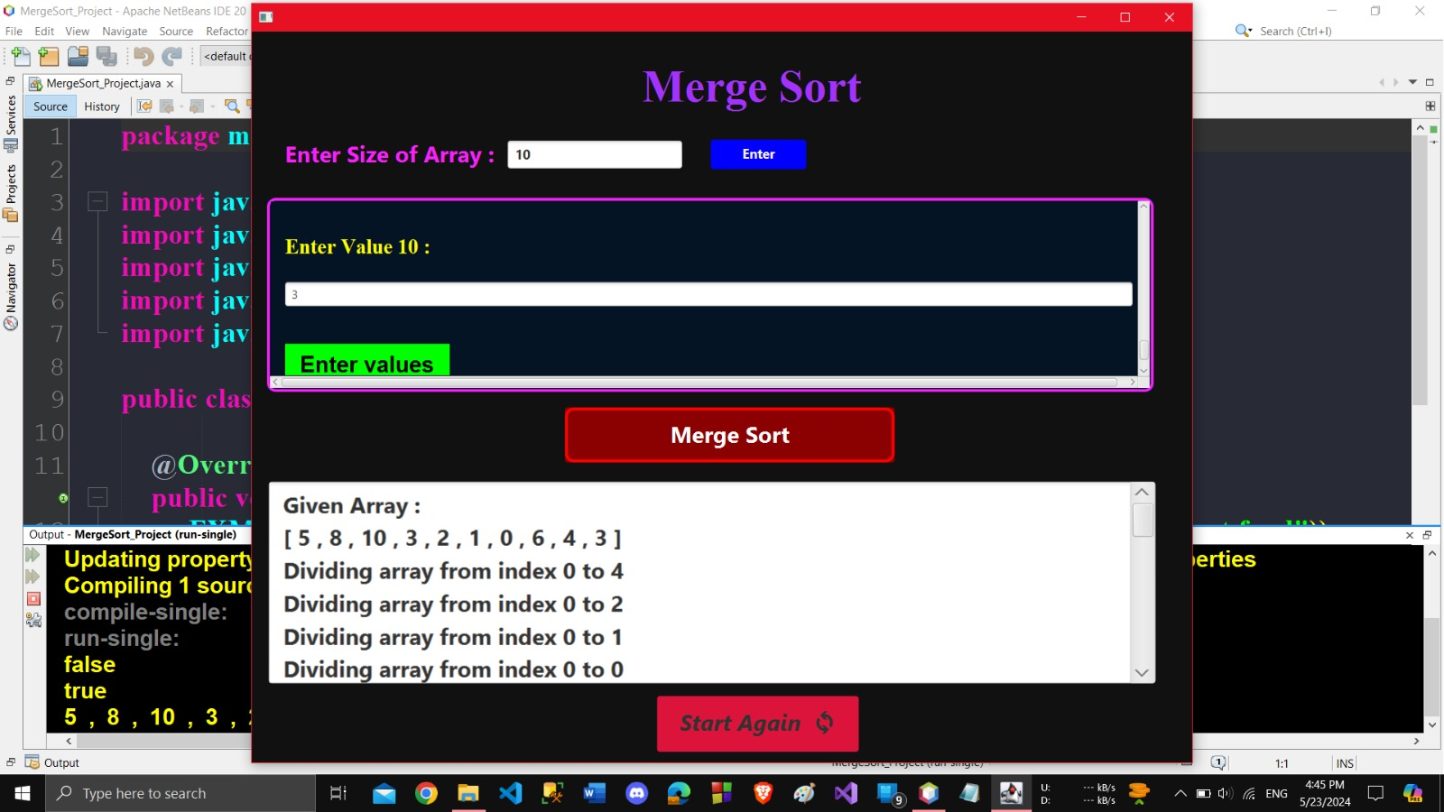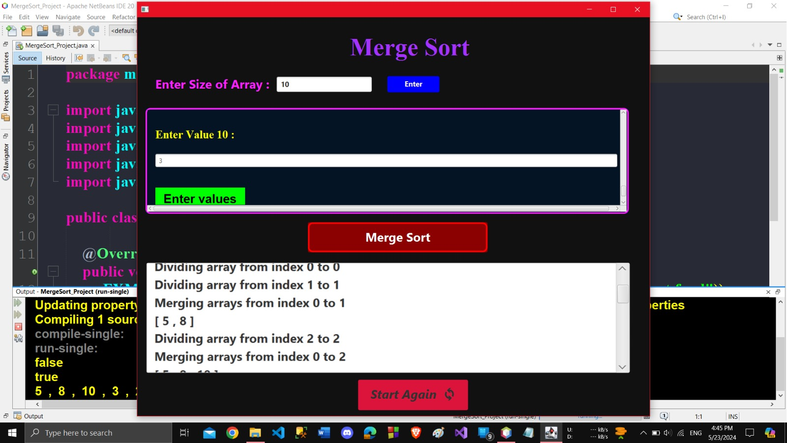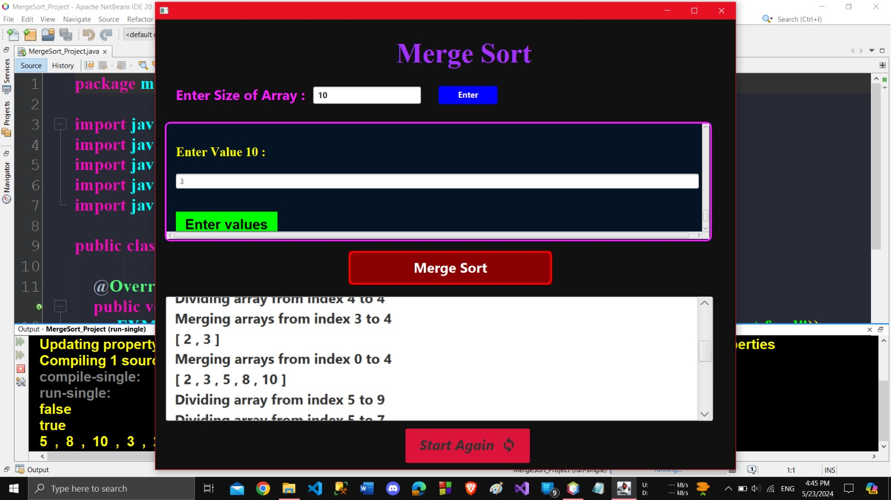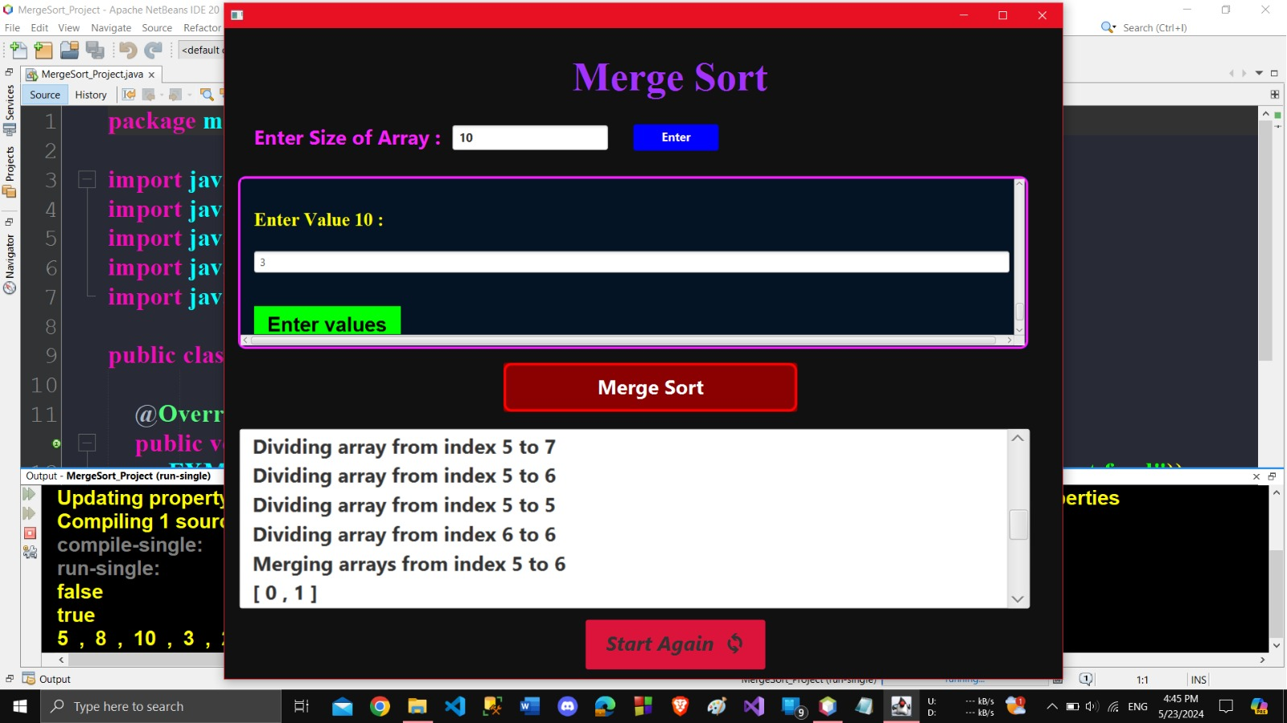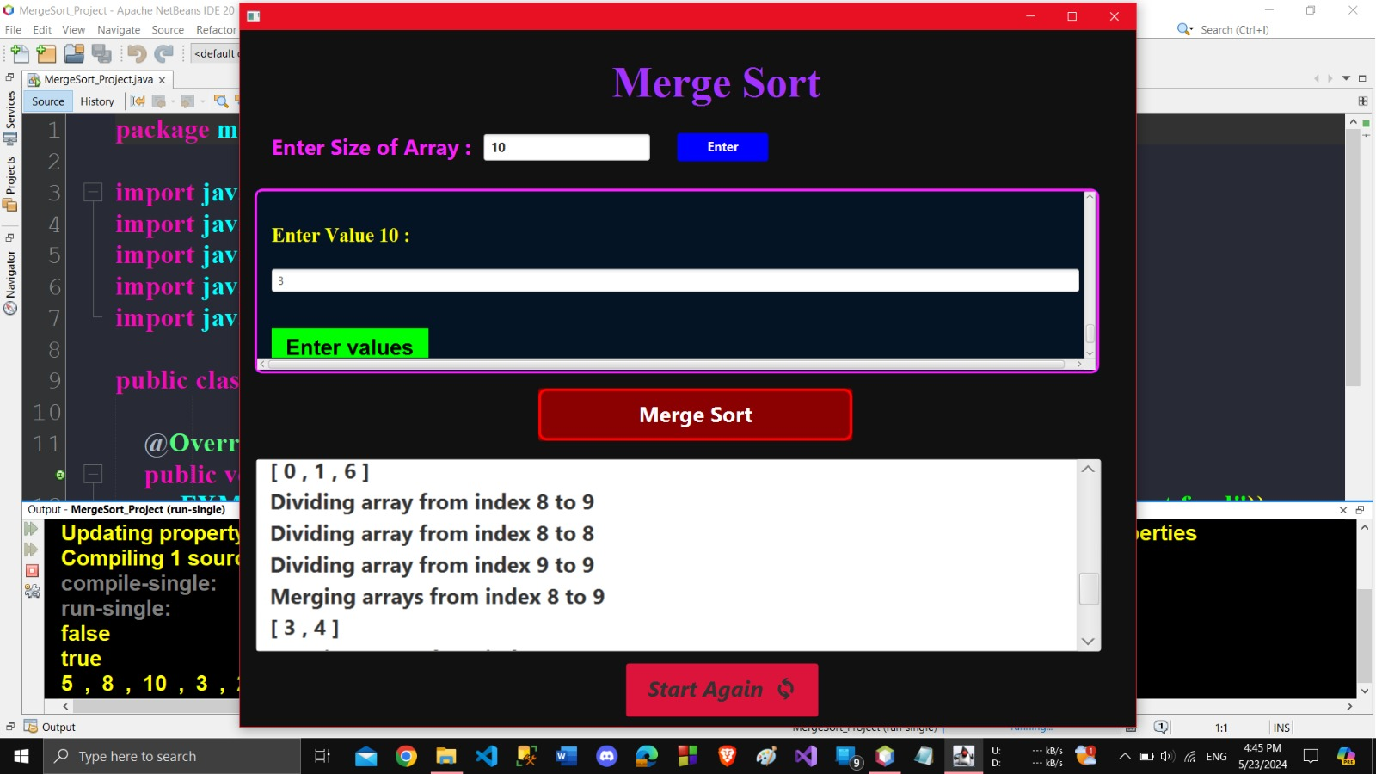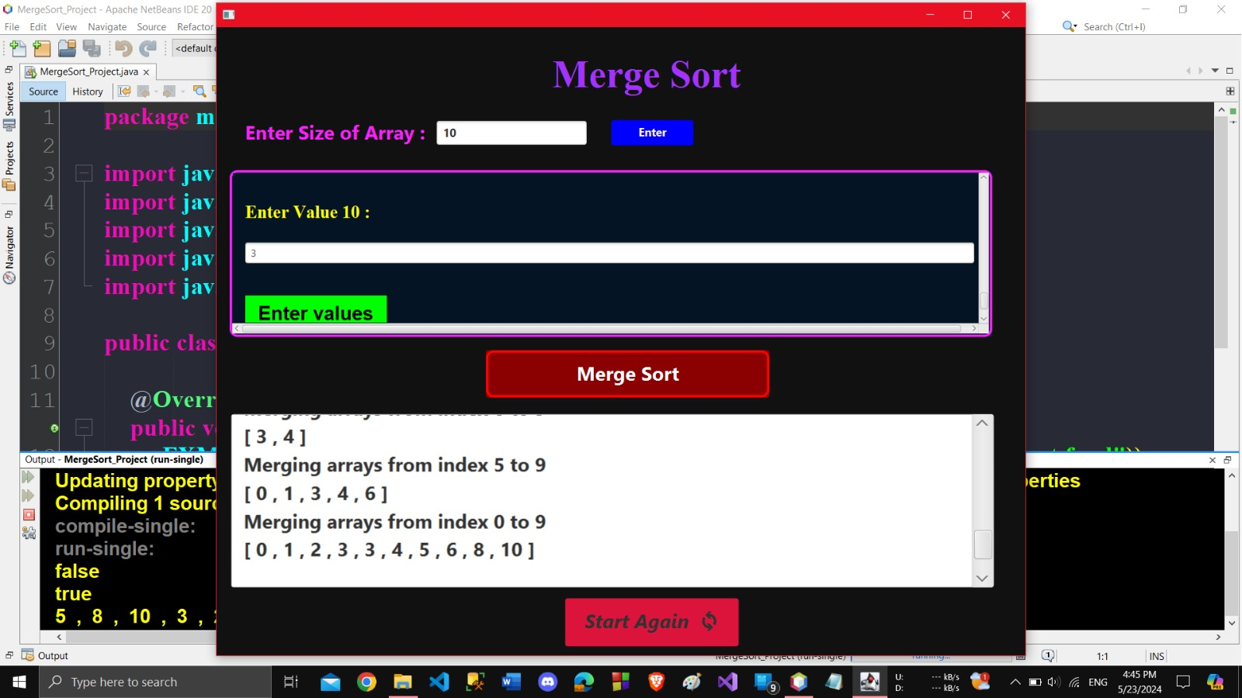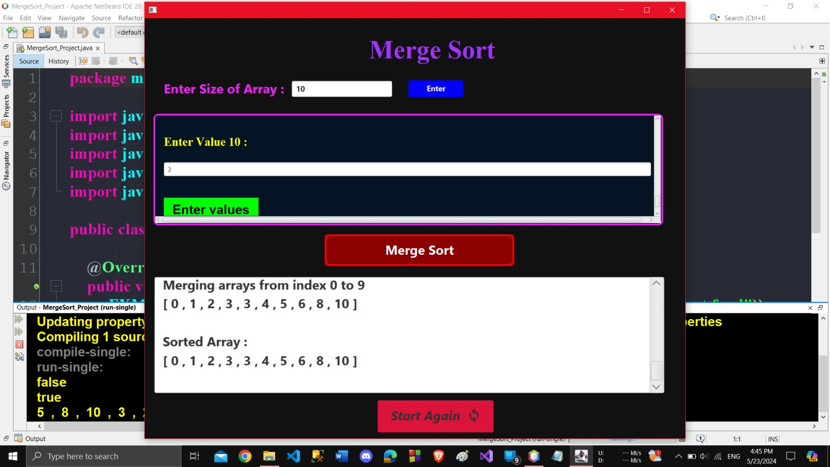

**Discussion:**

Merge Sort offers a guaranteed time complexity of O(n log n) in both average and worst-case scenarios, making it highly efficient for large datasets. The divide-and-conquer approach simplifies the sorting process and allows for parallelization in certain situations. However, it requires additional memory for storing the sub-lists during the divide and conquer steps.

The JavaFX application provides a user-friendly way to visualize the sorting process and interact with the algorithm. This can be a valuable tool for understanding the logic behind Merge Sort.

**Conclusion:**

**Merge sort is a highly efficient sorting algorithm with a stable performance. Through the implementation of a GUI application, the algorithm's functionality and effectiveness have been visually demonstrated. This project not only serves as a learning tool for understanding merge sort but also highlights the importance of graphical interfaces in simplifying complex algorithms for users.**